**Assignment– 3**

|  |  |
| --- | --- |
| AssignmentDate | 31 october2022 |
| Team ID | PNT2022TMID50302 |
| ProjectName | Inventory Management for Retailers |
| MaximumMarks | 2Marks |
| Batchno. | B2-2M4E |

Question1:

CreateaBucketinIBMObjectStorage.

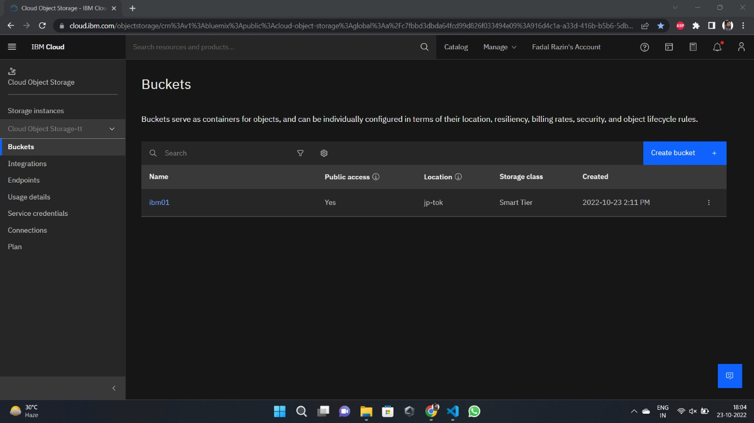

Question2:

Upload an 5 imagesto IBM object storage and make it public. write html code to displayingallthe5images.

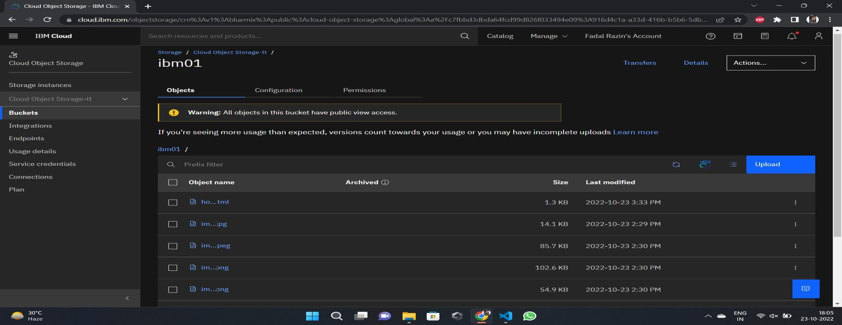

Question3:

UploadaCSSpagetotheobjectstorageandusethesamepage inyourHTMLcode.

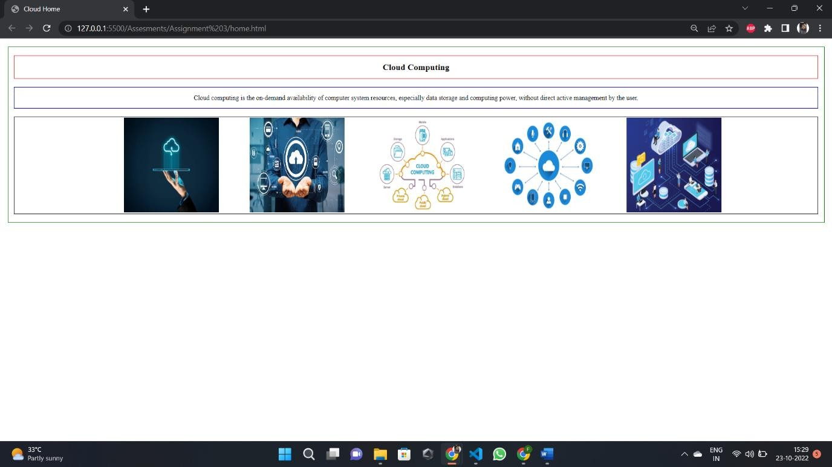

Question4:

Design a chatbot using IBM Watson assistant for hospital. Ex: User comes with query toknowthebranchesforthathospitalinyourcity.SubmitthewebURLofthatchatbotasaassignment.

[**https://web-chat.global.assistant.watson.appdomain.cloud/preview.html?backgroundImageURL=https%3A%2F%2Fau-syd.assistant.watson.cloud.ibm.com%2Fpublic%2Fimages%2Fupx-3c53ca7b-ce74-4ac8-b25c-8f69b083274a%3A%3A443fb1bd-945b-4727-b6f4-1929720ae6ff&integrationID=3d5eea10-931a-4d86-9986-77ae1738437a&region=au-syd&serviceInstanceID=3c53ca7b-ce74-4ac8-b25c-8f69b083274a**](https://web-chat.global.assistant.watson.appdomain.cloud/preview.html?backgroundImageURL=https%3A%2F%2Fau-syd.assistant.watson.cloud.ibm.com%2Fpublic%2Fimages%2Fupx-3c53ca7b-ce74-4ac8-b25c-8f69b083274a%3A%3A443fb1bd-945b-4727-b6f4-1929720ae6ff&integrationID=3d5eea10-931a-4d86-9986-77ae1738437a&region=au-syd&serviceInstanceID=3c53ca7b-ce74-4ac8-b25c-8f69b083274a)

Question5:

CreateWatsonassistantservicewith10stepsanduse3conditionsinit.LoadthatscriptinHTMLpage.

